# Input CSV Sample:

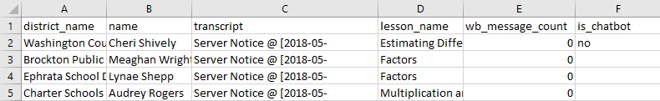

# After filter – Original DF



# Transcript DF – Each Transcript is Made into It’s Own Dataframe. Here is an example of 1.



Summary data from Transcript_df is then returned back up to the original DF as new columns . For example student_bool and line_char_length are used to figure out average_teacher_response_length

# DF with Each Transcript Summary Data Columns (columns O-U)

